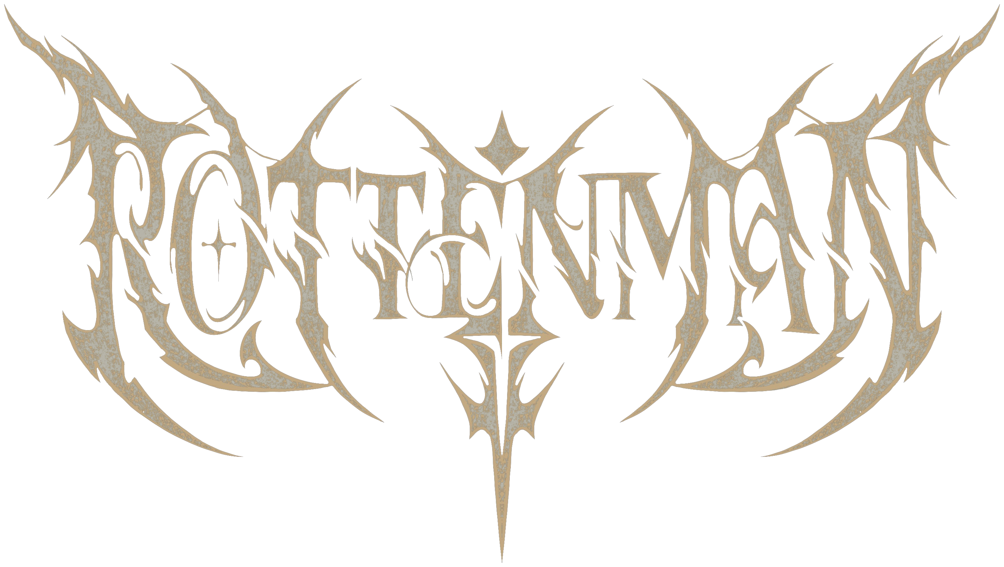
BAND & TECHNICAL RIDER
Hardcore metal from Austria and Spain
July 2026

BAND RIDER
About the Band
Rottenman was formed on 03.04.2026 and brings together members from Rottenmann, Graz and Vienna (Austria) as well as Galicia (Spain). The band plays hardcore metal with slam and death influences — intense, high-energy songs built on impact and directness.
Line-up
- Julian Hölzl — Vocals
- Jan Duinkerken Rodriguez — Guitar
- Rene Kayr — Bass
- Stefan Manhartseder — Drums
Releases
The debut EP is currently in the works and not yet released. The first single “Falling Back” has been released on all streaming Platforms
Past Shows
- Ranch Rock Festival — June 27, 2026
Contact & Social Media
Instagram: instagram.com/rottenman.band
Contact Person | Julian Hölzl (Vocals / Organizer)
Email | jul.hoelzl1@gmail.com
Phone | +43 664 3483760
Instagram | instagram.com/rottenman.band

TECHNICAL RIDER
General
On-stage personnel: 4 people (vocals, guitar, bass, drums), optionally a 5th with a second guitarist. Guitar and bass run entirely through modelers (Line 6 Helix Stomp) direct into FOH — no backline amp, no miking required. Playback/sample elements come from a dedicated hardware unit (LP-16), signal mono. The drum kit should ideally be provided in full by the venue — see Backline for details.
FOH Signal Chain
Guitar and bass are each fed balanced (DI/line) directly into FOH via a Line 6 Helix Stomp — no instrument mic and no amp/cab required. An optional second guitarist would likewise be fed via a third Helix Stomp, or as an additional channel through the LP-16. Vocals run through an own microphone directly into FOH; a house mic is fine as an alternative. Playback/sample elements come from the LP-16 on a mono channel.
Input List
Ch | Source | Signal / Mic | Note
1 | Kick In | Mic (Venue) | Drum kit – venue backline
2 | Kick Out | Mic (Venue) | Drum kit – venue backline
3 | Snare Top | Mic (Venue) | Snare: own snare will be brought
4 | Hi-Hat | Mic (Venue) | Drum kit – venue backline
5 | Tom 1 | Mic (Venue) | Drum kit – venue backline
6 | Tom 2 / Floor Tom | Mic (Venue) | Drum kit – venue backline
7 | Overhead L | Mic (Venue) | Drum kit – venue backline
8 | Overhead R | Mic (Venue) | Drum kit – venue backline
9 | Guitar 1 (Jan) | Line / DI | Helix Stomp – direct into FOH, no amp
10 | Guitar 2 (optional) | Line / DI | via LP-16, if a 2nd guitarist is present
11 | Bass (Rene) | Line / DI | Helix Stomp – direct into FOH, no amp
12 | Playback (LP-16) | Line, mono | 1 channel, samples/backing – dedicated hardware unit
13 | Vocals (Julian) | Mic (own mic, house mic OK as backup) | direct into FOH
Channels 1–8 (drums) follow the venue’s own drum mic setup — the exact number may vary depending on the kit.

Monitoring
We need 4 separate wedge mixes:
Mix | Position / Recipient | Type
1 | Drums (Stefan) | Wedge
2 | Vocals (Julian) | Wedge
3 | Guitar (Jan) | Wedge
4 | Bass (Rene) | Wedge
Backline — Provided by the Band
- 1x electric guitar
- 1x electric bass
- Snare (own)
- 1–2 cymbals (own)
- 3x Line 6 Helix Stomp
- LP-16 (playback hardware)
Backline — Required from the Venue
- Full drum kit (bass drum, toms, hardware, throne) — except for the parts listed above that we bring ourselves
- Drum kit microphones
- House vocal mic as backup (optional)
Power Supply
- Power outlet at the drum kit (upstage)
- Power outlet at the front of the stage (for Helix Stomp / LP-16)

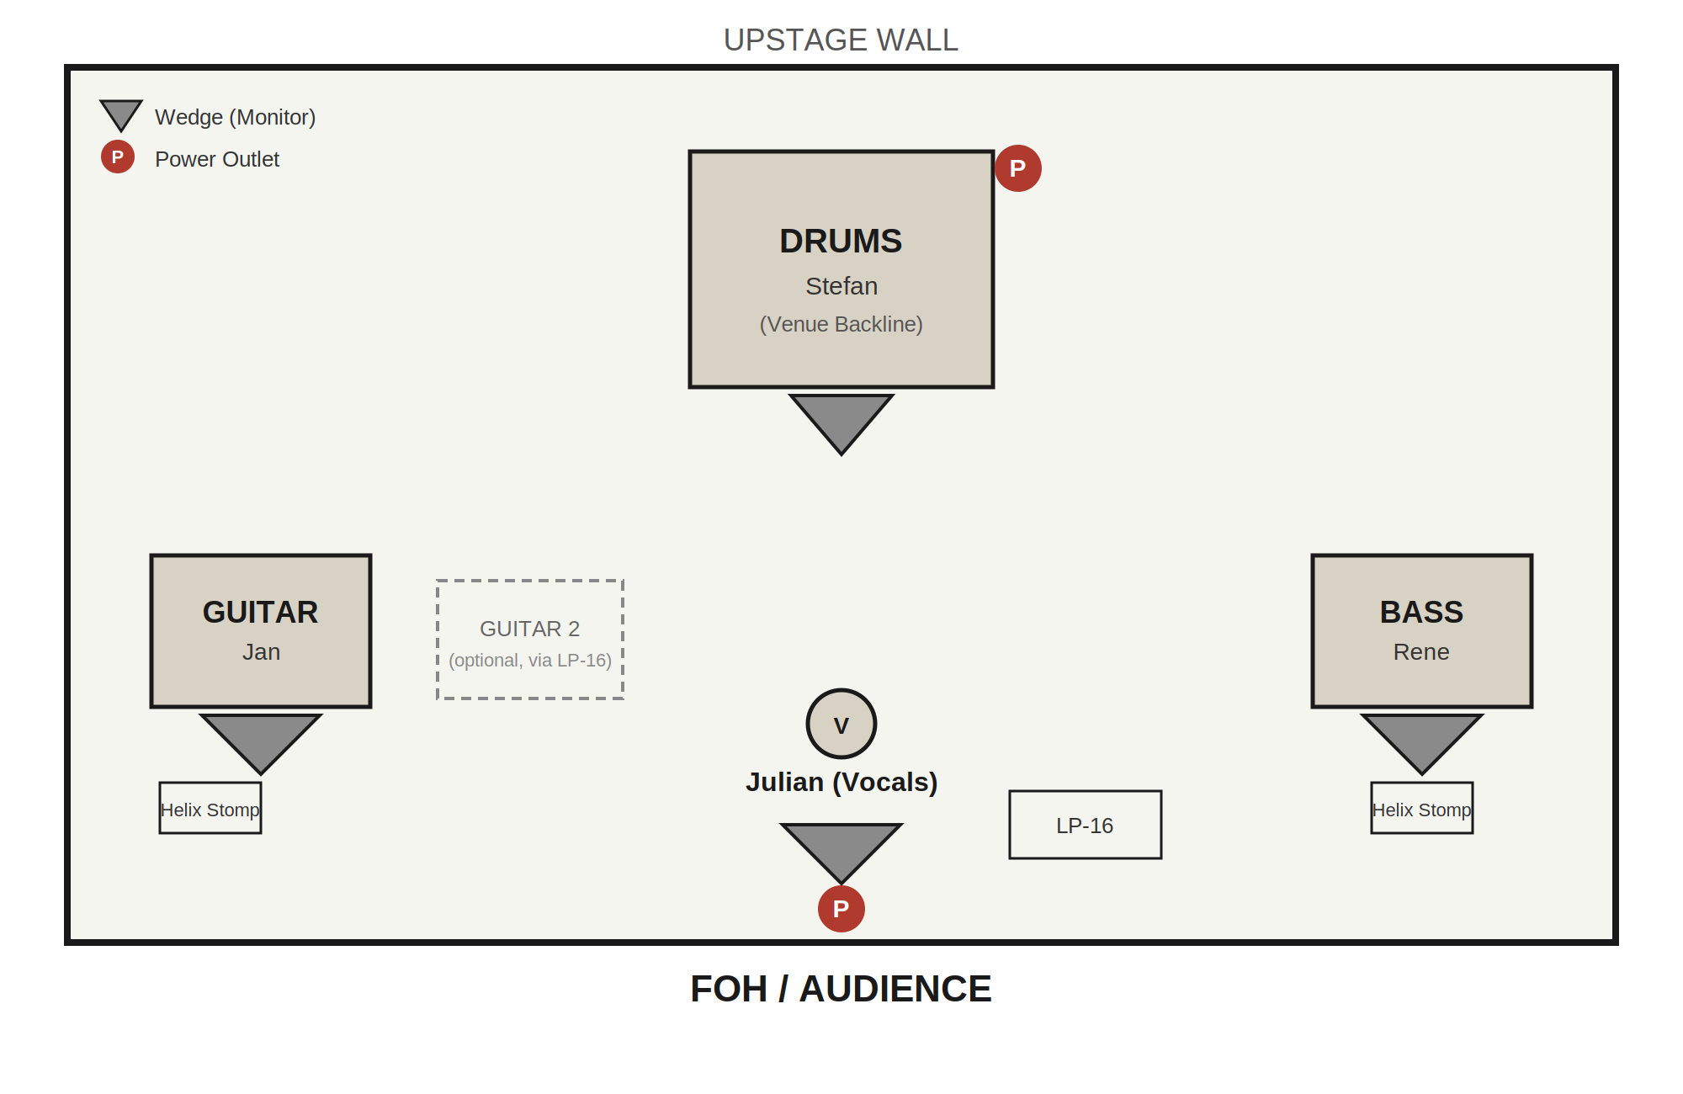

ROTTENMAN

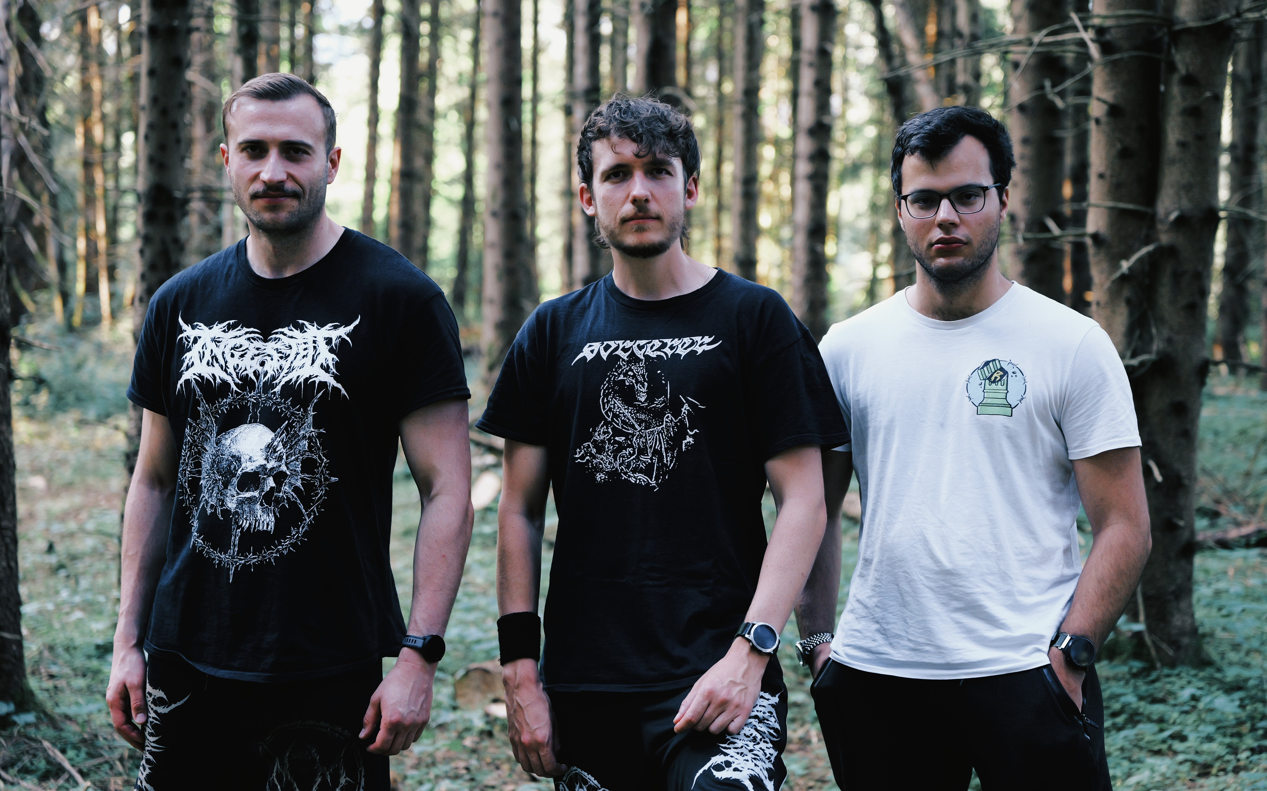

instagram.com/rottenman.band

